1.INTRODUCTION

1.1 OVERVIEW

**Personalized Invitations Using Canva**

1.2 PURPOSE

FOR MARRIAGE

T O INVITE FRIENDS AND RELEATIVES

2.PROBLEM DEFINATION AND DESIGN THINKING

2.1 EMPATHY MAP

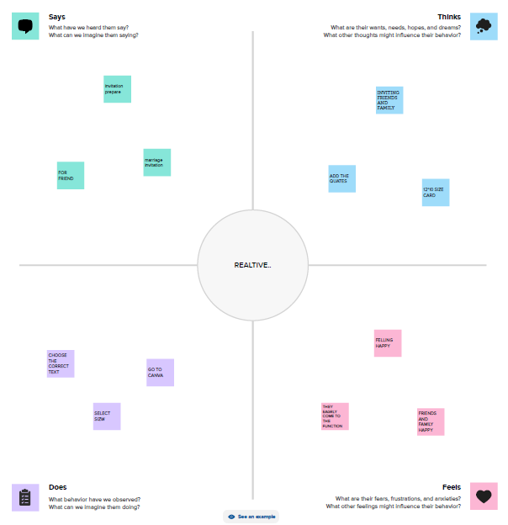

2.2 BRAIN STORM

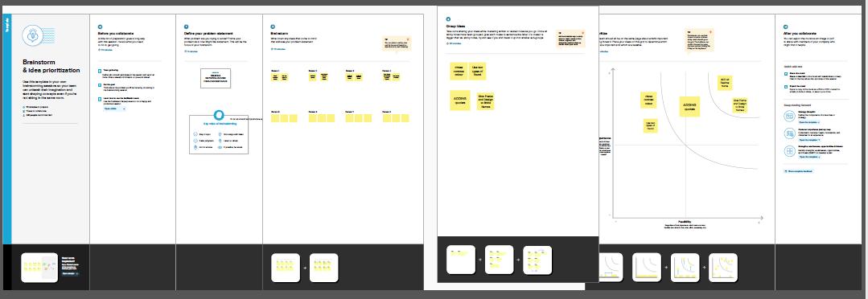

3.RESULT



4.ADVANTAGES AND DISADVANTAGES

ADVANTAGES

EASYLE accessible

VERY CREATBLE DISADVAN TAGE

DISADVANTAGES

SOME designs ask money

5.APPLICATIONS

TO INVIATE FRIENDS

6.Conclusion

LEARN HOW TO MAKE A LOGO DESIGN.IT IS VERY USEFUL TO DEVLOP CREATIVE THING AND DESIGNING IDEAS